**GOVERNMENT DEGREE COLLEGE, GUMMALAKSHMIPURAM**

**Name of the Event: Awareness to the Adolescent Student**

**Guest of Honor : Dr T. Sreevaram Principal**

**Date                      : 30-09-2024**

**Organized by           : Women Empowerment Cell**

**Lecturers Attended: 06**

**Students Attended: 70**

**Government Degree College, Gummalakshmipuram Women Empowerment Cell Co-coordinator A. Srivani organized an awareness programme to the adolescence of “RASHTRIYA KISHOR SWASTHYA KARYAKRAMAM”. On this event**Smt **P. prameela AHC took a counseling session under the president ship of Dr. T.Sreevaram principal of Government Degree College**

**Smt P. Prameela garu equipped the girl students with the A to Z awareness about physical health, mental health, Hygiene etc, nearby 86 students and women staff participated and made the event successful.**

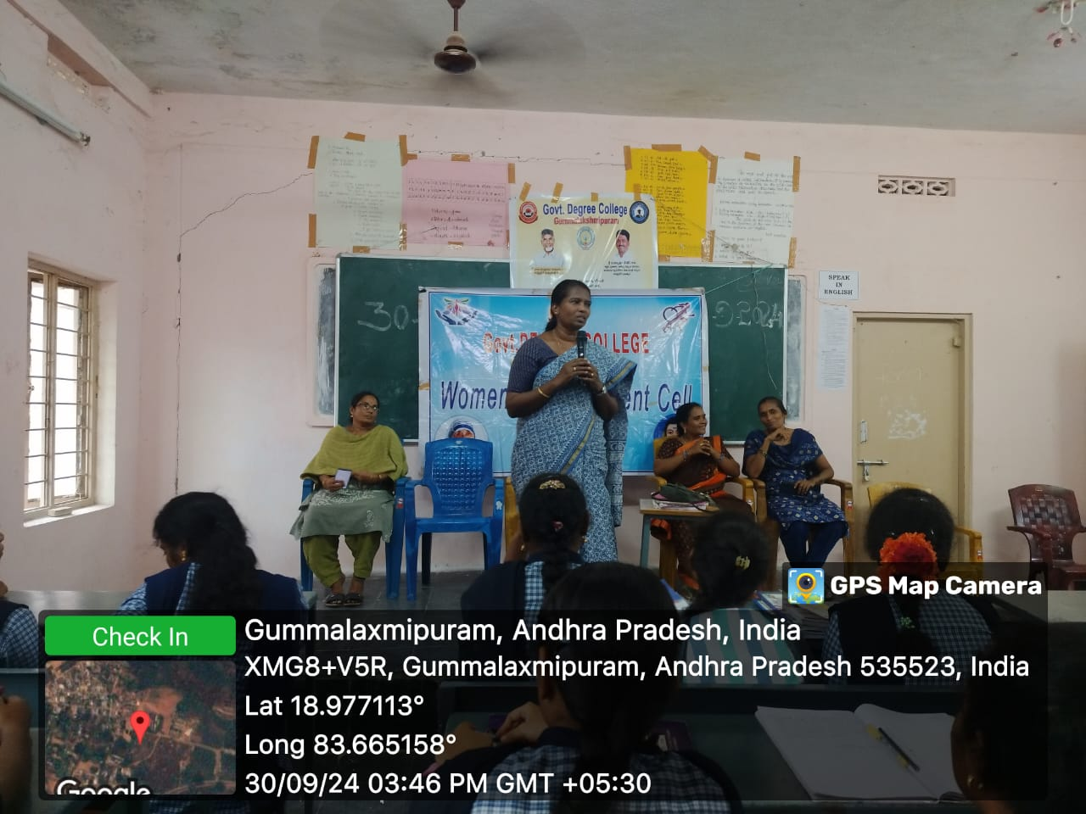

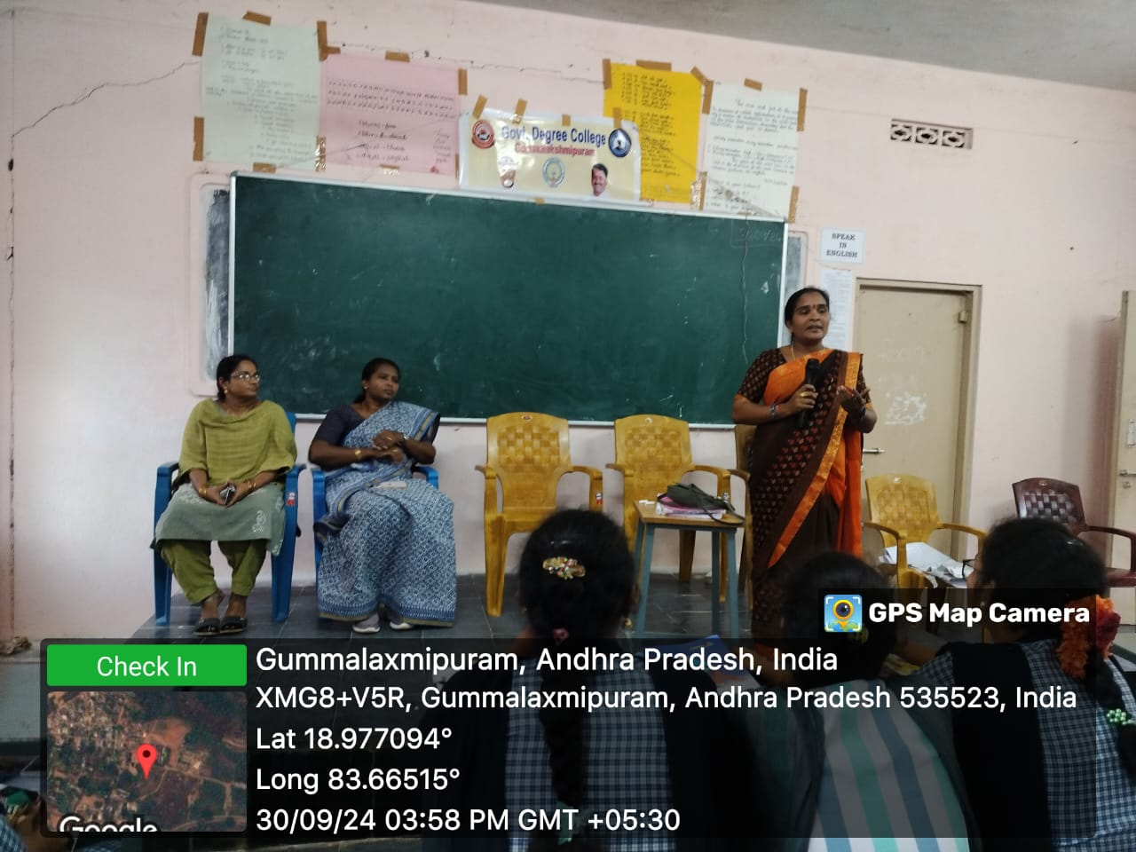

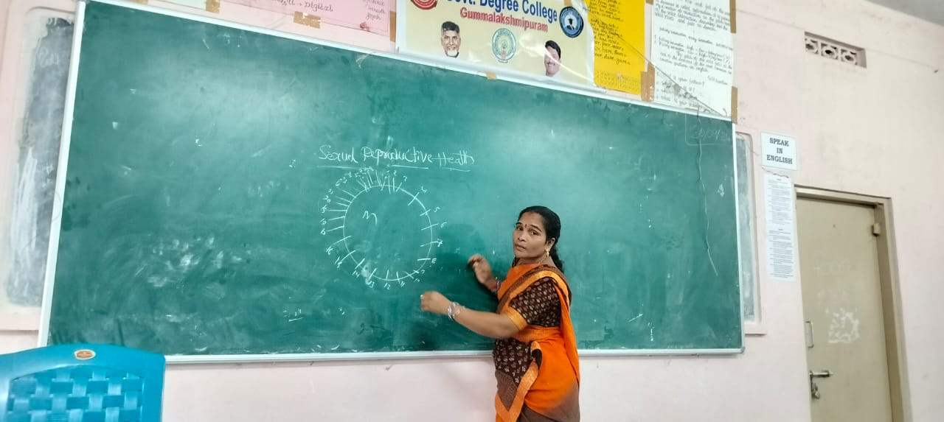

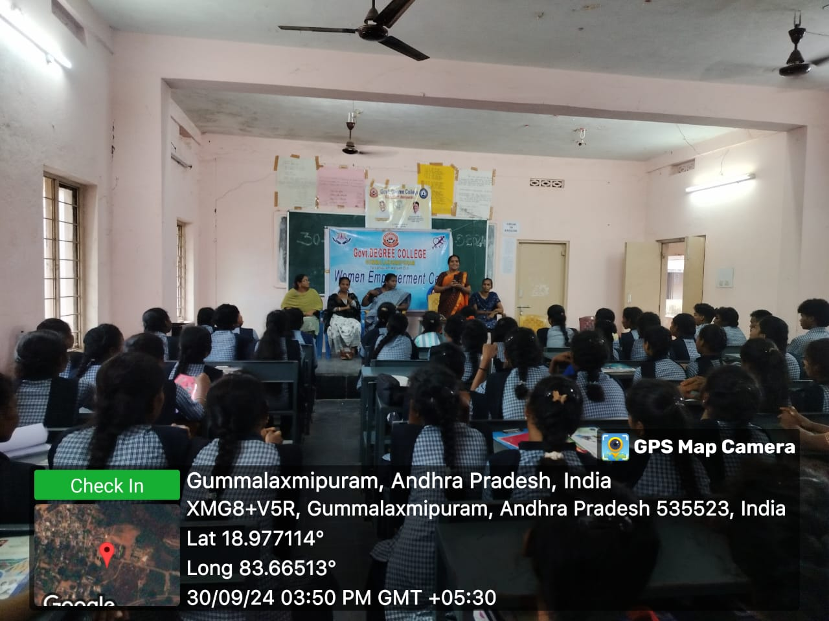

**Conclusion: Awareness among adolescent students is crucial for their personal growth, decision-making, and overall well-being. By educating them about important topics such as mental health, substance abuse, online safety, and personal development, we empower them to make informed choices. Schools, parents, and society must work together to provide a supportive environment where students can openly discuss their challenges and seek guidance. When adolescents are well-informed, they become responsible individuals who contribute positively to their communities and future.**